2APHY: Motion and Force:

Test 1: Vectors and Motion ANSWERS
28 marks for working + 2 marks for correct units and significant figures: total 30 marks
Outcomes:
- distinguish between scalar and vector quantities
- add and subtract vectors in one dimension
- describe and apply the concepts of distance and displacement, speed and velocity, and acceleration for uniform and uniformly accelerated rectilinear motion, including vertical motion under gravity—this will include applying the relationships:
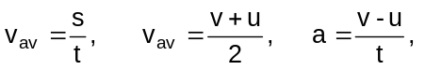

Time: 60 minutes

- A student was answering a question. An elephant walks 300 m West then 400 m East, what was the displacement of the elephant? The student gave the answer as 100 m. Was he correct? Explain? (2 mark)

Numerically the answer is correct but as displacement is required then a direction should be given.

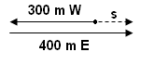
Therefore numerically the answer is 100 m but the direction is east. [1 mark]

s = 100 m East [1 mark]

- A footballer throws a football to a team member 6.50 m east. He then runs backwards 5.00 m west whereupon the ball is thrown back to him. Determine the distance and displacement of the ball. (2 marks)

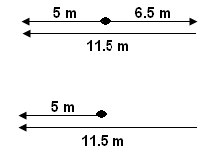
distance = 6.5 + 11.5
distance = 18.0 m [1 mark]

displacement is shortest distance from start to finish so

s = 5.00 m West [1 mark]

- Cheetahs, the fastest land animal, can reach speeds of over 100 kmh⁻¹ for short distances. A cheetah, travelling at 9.00 ms⁻¹, sees a zebra in front of it and reaches a velocity of 25.0 ms⁻¹ to catch its prey. What was the cheetah’s acceleration during this time if the chase took 3.00 s.
(2 marks)

u = 9.00 ms⁻¹ 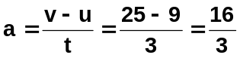 [1 mark]
v = 25.0 ms⁻¹
t = 3.00 s a = 5.33 ms⁻² [1 mark]

- John is running around a circular track at a constant speed. He takes 4.00 minutes to cover 8.00 x 10² m and returns to the start.
- What was his speed? (2 marks)

dist = 800 m 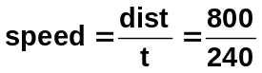 [1 mark]
t = 4 x 60 speed = 3.33 ms⁻¹ [1 mark]
= 240 s

- What was his velocity half way around the track (assume it took 2.00 minutes)? (3 mark)
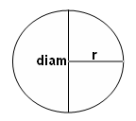
circum = πd 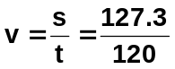 [1 mark]
400 = πd
d = 127.3 m v = 1.06 ms⁻¹
[1 mark] [1 mark]

t = 2 x 60
= 120 s

- Explain why a motorbike, travelling around a corner at a constant speed, is accelerating.
(3 marks)
Speed is a scalar quantity so has a magnitude but no direction.
Velocity is a vector quantity so needs a magnitude and a direction. [1 mark]
If in velocity, the direction changes then so does the velocity even if the magnitude is the same. [1 mark]
Now acceleration is change in velocity over time so if the direction changes, the velocity changes and the motorbike is accelerating. [1 mark]

- A speedboat is travelling down a straight river at 14.8 ms⁻¹. The speedboat then accelerates at 1.60 ms⁻² for 4.50 s. How far did the speedboat travel during this time? (2 marks)

u = 14.8 ms⁻¹ s = ut + ½ at²
a = 1.60 ms⁻² s = (14.8 x 4.50) + (0.5 x 1.6 x 4.5²) [1 mark]
t = 4.50 s s = 66.6 + 16.2
s = 82.8 m [1 mark]

- Victoria sees a traffic light turn orange when she is 25.0 m from it. She has a reaction time of 0.300 s and is travelling at 16.2 ms⁻¹. If the car can decelerate at 7.60 ms⁻², will she stop in time for the traffic light? (4 marks)

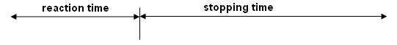
t = 0.300 s displacement in which to stop = 25 – 4.86 = 20.14 m
u = 16.2 ms⁻¹ need to find actual displacement
u = 16.2 ms⁻¹
s = ut v = 0 ms⁻¹
= 16.2 x 0.30 a = -7.60 ms⁻² v² = u² + 2as
= 4.68 m 0 = 16.2² + (2 x -7 x s) [1 mark]
0 = 262.44 – 14s
[1 mark] 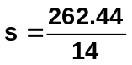
s = 18.7 m [1 mark]

as she has 20.14 m in which to stop and can stop in 18.7 m then she will stop in time.
[1 mark]

- While working on a demolition job, a workman throws a tile down to the ground below with an initial velocity of 1.90 ms⁻¹. What was the tile’s velocity if it hit the ground 2.58 s after being released? (2 marks)

u = 1.9 ms⁻¹ v = u + at
g = 9.8 ms⁻² v = 1.9 + (9.8 x 2.58) [1 mark]
t = 2.58 s v = 1.9 + 25.284
v = 27.184

v = 27.2 ms⁻¹ [1 mark]

- You are in a helicopter which is ascending at 2.90 ms⁻¹ when you look out of the door and your sunglasses fall off. Assuming no air resistance, how long before the sunglasses hit the ground if they fell out when your head was 255 m above the ground? (3 marks)

up is positive If you have solver on your calculator
u = +2.90 ms⁻¹ s = ut + ½ gt²
s = -255 m -255 = 2.9t – 4.9t² [2 marks]
-4.9t² + 2.9t + 255 = 0
t = 7.52 s [1 mark]

OR Without solver
v² = u² + 2gs 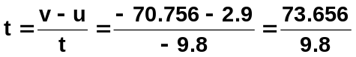
= 2.9² + (2 x -9.8 x -255) t = 7.52 s
= 8.41 + 4998 [1 mark]
= 5006.41
v = 70.756 ms⁻¹ down
[2 marks]

- In a cartoon, the white spy is trying to escape the black spy. The white spy is on a ledge 80.0 m directly above a road when he sees the black spy in a car travelling towards him at a constant velocity of 12.4 ms⁻¹. The white spy drops a large rock off the ledge when the black spy is 50.0 m from the point on the road directly below the ledge. Does the white spy stop the black spy and therefore get away? Show all working to justify your answer. (3 marks)

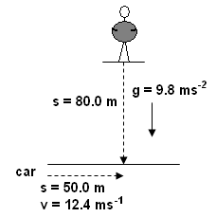
Car Rock

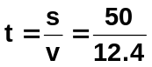 s = ut + ½ gt²
80 = 0 + (0.5 x 9.8 x t²)
t = 4.03 s 80 = 4.9t²
[1 mark] t = 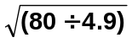
t = 4.04 s
[1 mark]

As times so close, the rock does land on the black spy’s car and stops him allowing white spy to escape.
[1 mark]

